Manage_sensors.krl URL:

HTML test script URL:

Angular test script URL:

I did not make changes to the other rulesets

**Diagram**:

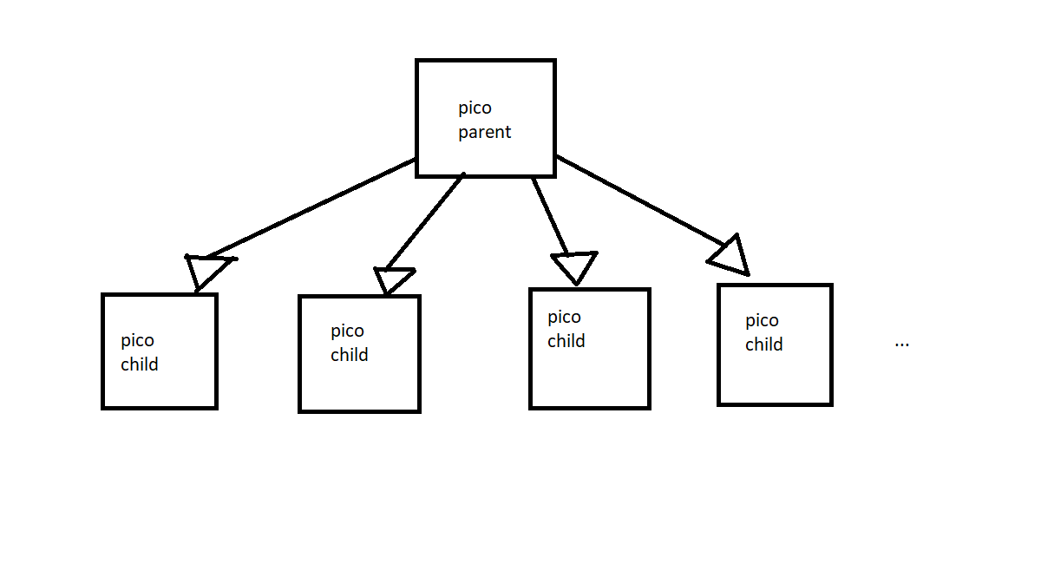

1. How did your rule that creates the sensor pico install rules in the new child pico?

My rule raises a “child_creation” wrangler event with some attributes. And one of these attributes is called “rids” which is an array of rule ids. So I just added all the rules names/ids on that array and sent as an attribute to the child_creation event.

1. How did you ensure that your sensor picos were created before sending them the event telling them their profile was updated?

After the “child_creation” wrangler event is raised, the wrangler “child_initialized” is raised on my ruleset if the child was created successfully. Inside of my child_initialized ruleset, I programmatically send a “sensor/profile_update” event to the child pico. So the profile is updated only if the child is initialized properly.

1. How did you create a test harness for your pico system?

I created it using HTML and angular. I basically send event request to pico when I press the buttons on my website. Those requests create two pico childs, delete one of them, it add a temperature to one of them and retrieve it from the child, and it update the profile of the child and retrieve the stored profile. Everything is displayed to make sure all my rules are working as expected.

1. In this set up, the picos representing sensors don't need to talk to each other and the sensor management pico is the parent, so it has channels to each child. How could you provide channels between sensor picos if sensor-to-sensor interaction were necessary?

I believe I could create a ruleset that contains a list of brother picos. So when the parent pico creates each child pico, the parent pico send the list of its children (wovyn:children()) to it. The parent also update the list of every child pico when a new child is created. So I believe every child would have access to its brother if this is implemented correctly.